

Foundations of Programming

Assignment No.: 15
PROBLEM STATEMENT: Write a C program to generate pseudo random numbers.

OBJECTIVE:

- To understand the concept of pseudo random numbers.
- To learn the use of rand() and srand() functions in C.
- To generate random numbers using the standard library.
- To understand the role of header files in C programming.

THEORY:
In C programming, pseudo random numbers are generated using the rand() function available in the stdlib.h header file. These numbers are not truly random but are generated using a deterministic algorithm. The srand() function is used to set the seed value for random number generation. Usually, the current time is used as a seed to produce different sequences of numbers each time the program runs.

PLATFORM: Linux
CODE:
#include <stdio.h>
#include <stdlib.h> // Required for rand() and srand()
#include <time.h> // Required for time()

int main() {
int n, i;

// Ask the user how many random numbers they want to generate
printf("Enter the number of random numbers to generate: ");
scanf("%d", &n);

// Seed the random number generator using the current system time.
// If we don't do this, rand() will produce the exact same sequence
// of numbers every time the program is executed.
srand(time(NULL));

printf("\n--- Generated Pseudo-Random Numbers ---\n");
for (i = 0; i < n; i++) {
// rand() generates a random integer between 0 and RAND_MAX
printf("%d\n", rand());
}

// --- Bonus: Generating numbers within a specific range ---
printf("\n--- 5 Random Numbers between 1 and 100 ---\n");
for (i = 0; i < 5; i++) {
// Use the modulo operator (%) to restrict the range
// rand() % 100 gives 0 to 99. Adding 1 shifts it to 1 to 100.
int bounded_random = (rand() % 100) + 1;
printf("%d\n", bounded_random);
}

return 0;
}

INPUT AND OUTPUT:
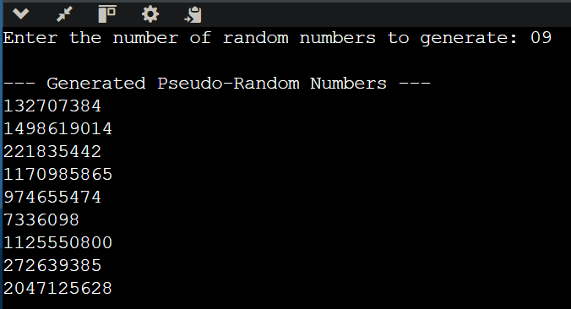

CONCLUSION: Thus, the C program successfully generates pseudo random numbers using the rand() function and srand() for seeding.

